TITLE herE (UPPER CASE, DO NOT CHANGE FONTS)

FirstnameA SurnameA^{1,2}, FirstnameB SurnameB^{1,*}, FirstnameC SurnameC² (the presenting author underlined)

¹Affiliation1, address1
²Affiliation2, address2
*corresponding.author@email.address

ABSTRACT

Please stick to the format of this template in all respects (fonts, sizes, spacing etc.). For inserting figures, follow the examples below.
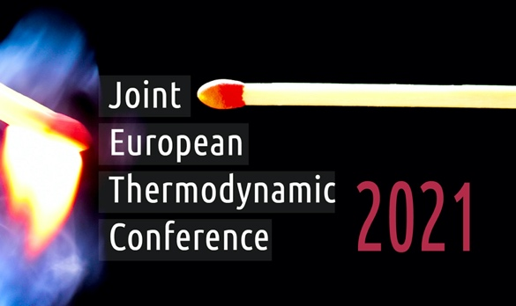

Figure 1: Type figure caption here.

Number references in the order of appearance. Refer to cited literature by its number in square brackets. References should be styled and punctuated according to the following examples: journal article [1], book [2], thesis [3], report [4], proceedings [5], and edited book [6]. Always give inclusive page numbers for references to journal articles and a page or chapter number for books. Each reference must be cited in the text.
Generate a pdf file (with fonts embedded, i.e., in ISO 19005 compatible PDF/A format), and send us both the .pdf file and the source .doc(x) file.

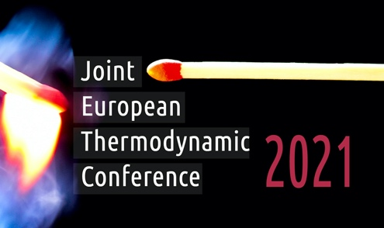  Figure 2: Type figure caption here. | 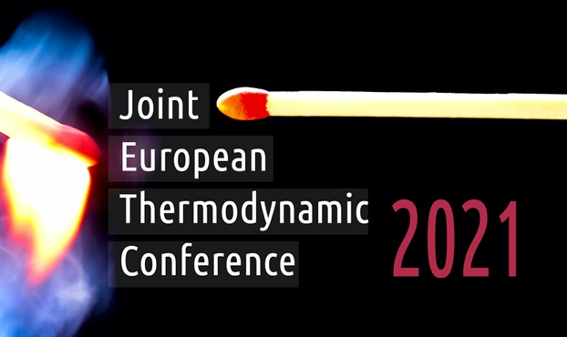  Figure 3: Type figure caption here.

The abstract must be longer than half a page but should not exceed one page in length and 2 MB in size. Thank you for your patience and cooperation. If needed we will make formatting corrections on your source file and send you the final version for your approval.

REFERENCES

[1] M.E. Braaten and W. Shyy, Study of Pressure Correction Methods with Multigrid for Viscous Flow Calculations in Nonorthogonal Curvilinear Coordinates, Numer. Heat Transfer, vol. 11, pp. 417–442, 1987.
[2] Y. Jaluria and K.E. Torrance, Computational Heat Transfer, Hemisphere, Washington, D.C., 1986.
[3] C. Graham, The Limiting Heat Transfer Mechanism of Dropwise Condensation, Ph.D. thesis, Massachusetts Institute of Technology, Cambridge, Mass., 1969.
[4] E. Book and H. Bratman, Using Compilers to Build Compilers, Systems Development Corp. Rept. SP-176, Santa Monica, Calif., Aug. 1960.
[5] A.B. Caio, in Proceedings of the 12th Joint European Thermodynamics Conference (Brescia, Italy, July 1–5, 2013), eds. M. Pilotelli and G.P. Beretta (Snoopy, Brescia, Italy), pp. 101–106 (2013).
[6] W.B. Thompson, Kinetic Theory of Plasma, in M. N. Rosenbluth (ed.), Advanced Plasma Theory, chap. 1, Academic Press, New York, 1964.

